John Michael Go
Career Entry Level Java Programming
Date: Jan. 16, 2013

DAY 4

Program Name: Loop

Objective: Program will display the value of x starting from 10 to 20 using loop.

Algorithm:

- Program will display the value of x starting from 10 to 20 using loop.

Flowchart:

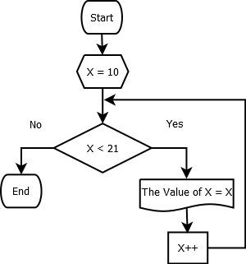

Pseudocode:

public class Loop {

public static void main(String[] args) {

for (int x = 10; x <21; x++){
System.out.println("The value of x = " +x);
}

}

}

Screenshot:

